ISTANBUL TECHNICAL UNIVERSITY

BLG 374E

Technical Communications for

Computer Engineers

Instructor: Damien Jade Duff

Final Report

Usability of Open Source

Video Editing Tools

7 May 2015

**Group UMANSIA**

Tuğrul Yatağan | 040100117

Emre Gökrem | 040100124

Gökberk Gülgün | 040100135

Group UMANSIA

Tugrul Yatagan | 040100117

Emre Gokrem | 040100124

Gokberk Gulgun | 040100135

Istanbul Technical University Ayazaga Campus

EEB Faculty Room 2104

Sariyer / Istanbul

34469

Saturday, 07 May, 2015

Mr. Damien Jade Duff

Istanbul Technical University Ayazaga Campus

EEB Faculty Room 2316

Sariyer / Istanbul

34469

Subject: Usability of open source video editing tools group final report

Dear Mr. Duff:

With this letter we give notice that we evaluated open source video editing tools; OpenShot and Kdenlive. Results of determined methods in determined parameters are emulated and open source video editing software are rated according to usability level.

The purpose of this research is that usability testing for different video editing software tools are analyzed and results are compared. According to these results, we came up with usability rate for video editing software. This process provides easy selection for users which need different using areas.

End of this study we concluded results in this final report.

We thank you for the professionalism.

Yours Sincerely

Group UMANSIA

*Signature Signature Signature*

Tugrul Yatagan Emre Gokrem Gokberk Gulgun

# Abstract

In this report, Kdenlive and OpenShot open source video editing tools are analyze according to selected methods which are software survey, task execution and participant feedback. After examining the methods, the result of this study gives usability information about stated open source video editing tools.

**Table of Contents**

Abstract 3

1. Introduction 4

2. Background 4

3. Methods 5

3.1 Software Survey 5

3.2 Task Execution 5

3.3 Participant Feedback 6

4. Results 6

4.1 Software Survey 6

4.2 Task Execution 6

4.2.1 Task Execution – Montage 7

4.2.2 Task Execution - Audio Effect 7

4.2.3 Task Execution - Video Effect 8

4.2.4 Task Execution – Toolbar Navigation 8

4.3 Participant Feedback 9

4.3.1 Participant Feedback – Learnability 9

4.3.2 Participant Feedback – Flexibility 10

4.3.3 Participant Feedback – Overall 10

5. Analysis 11

6. Conclusion 12

7. References 12

8. Appendix 13

# Introduction

In this report, Kdenlive and OpenShot open source video editing tools are analyze according to selected methods which are software survey, task execution and participant feedback. This study offers usability information and shows analyses of survey results about stated open source video editing tools.

Today, video editing process is very important area for IT users. However, different user profiles need different video editing features. Because of this, video editing tools have different usability rating for users.

In this study, OpenShot and Kdenlive open source video editing tools are compared according to different user profile. Then, usability rating is determined with collected survey data.

|  |  |  |
| --- | --- | --- |
| **TASK** | **DEADLINE** | **STATUS** |
| Requirement analysis | March 18 | Completed |
| Planning of processes | March 22 | Completed |
| Selection of participants | March 28 | Completed |
| Progress report | April 4 | Completed |
| Defining methods | April 10 | Completed |
| Participant feedback | April 10 | Completed |
| Task execution | April 12 | Completed |
| Software survey | April 12 | Completed |
| Preparation of document | April 15 | Completed |
| Presentation | April 17 | Completed |
| Final report | May 7 | Completed |

Table 1: Important Deadlines

# Background

Videos are everywhere in our live. Some video needs edit before publish and play. These software called video editing tools and they can be found as free software or priority software according to their license. Users demand user-friendly free software to edit videos. There are lots of open source video editing software out there but choosing user friendly and sufficient tool can be difficult. There must be a methodology to evaluate and choose appropriate tool. Without detailed information about technical details of video editing usability is chosen as a main criteria. Usability is very critical when subject is software so recommending or choosing video editing tool, usability is our first criteria. User friendly software means rapid and easy to use for users. But it can be relative so measuring user friendliness is a difficult subject. In academia, there are many papers written on software usability but there is no paper specific to video editing tools. As a result of these, these tools must be analyzed deeply and must be studied for usability for video editing. We will be using two of the most popular open source video editing software for our analysis which are Kdenlive and OpenShot.

# Methods

Three methods are used to analyze the usability of open source video editing software. These methods are software survey, task execution and participant feedback.

In software survey, the participants are questioned and information about their software knowledge is evaluated.

In task execution, the participant is expected to perform a specific tasks. The first one is to measure efficiency in software, the second one is for measuring learnability.

In participant feedback, different questions are asked about the software.

Total of 7 computer engineering students participated to the survey.

# Software Survey

Software survey participant selection criteria are user experience with video editing, user expertise level and user prior knowledge used OpenShot or Kdenlive.

In software survey group, participants divided into two group for OpenShot and Kdenlive video editing tools. Then questions were asked about video editing and user interface. They were shown sample videos made in OpenShot or Kdenlive according to their groups. Then the process of video editing was shown to them.

Different tasks has different weights on overall results. Weights of software survey are shown bellow

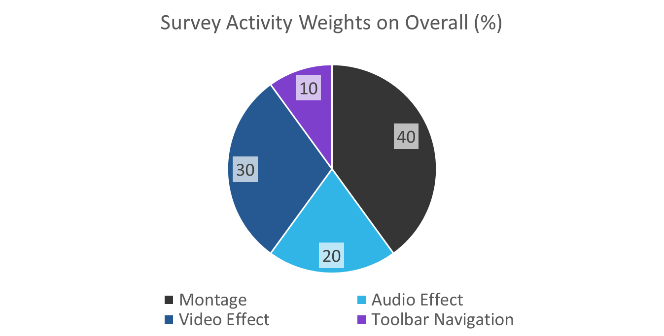

Figure 1: Survey Activity Weights

# Task Execution

In task execution survey group, participants were expected to perform several tasks like doing cut, copy, paste, toolbar navigation and applying audio & video effects. Participants were divided into three groups for Kdenlive, OpenShot and both

# Participant Feedback

In direct participant feedback survey group, the participants were shown how to use OpenShot and Kdenlive and their direct feedback was asked about some specific criteria. These considered criteria are learnability, flexibility, overall, compatibility, consistency, user guidance. Participants were divided into three groups again for Kdenlive, OpenShot and both.

# Results

In this section, the results of the survey are shown. After the study, software survey, task execution and participant feedback, we concluded final result. Our conclusion is OpenShot is better than Kdenlive on overall usability. But selection of usability tools can be relative to the usage area. Selection advices will be detailed in experiment results.

# Software Survey

The software survey is prepared to determine usability rating. Important actions in video editing tools are stated. The full content of survey is available in the Appendix section 8. 7 people have filled the survey. The 7 people were selected from university students on the computer engineering department. The participants are selected according to their old video editing knowledge level. The results of the survey is available in the Results section 4.3. Basically there are questions and there are answers. Each participant carefully gave answer. After this survey, we had diverse survey result of 7 people with different ideas and different capabilities.

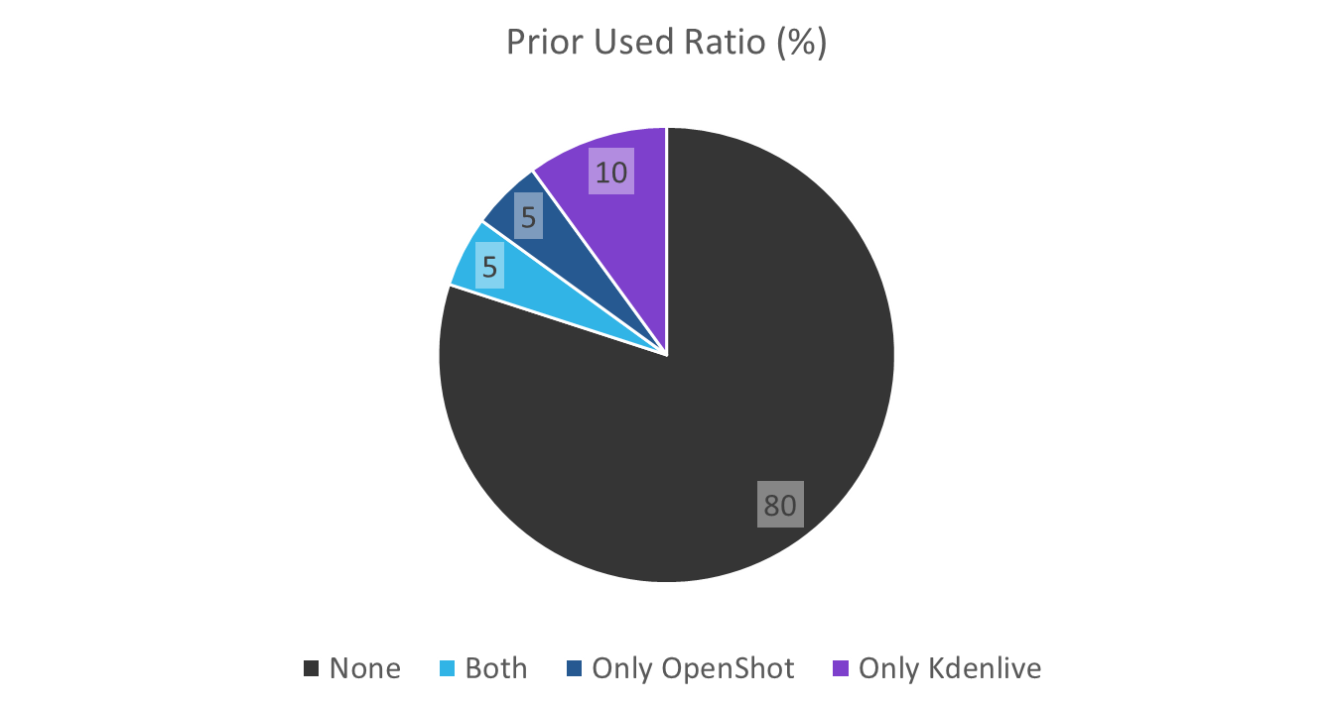Figure 2: Prior Knowledge

# Task Execution

Quantitative time based effort test is used to evaluate task execution usability of video editing tools. We asked participants to do some specific tasks and we measure the time it takes.

First task is video montage which contains cut, copy and paste tasks. Second one is adding video effect to original video. Third task is adding audio affect to original audio. Lastly we asked participants to find a tool in toolbar menu to measure participant’s toolbar navigation time.

These tasks gives us a quantitative data about usability of software tool. Participant’s performance were observed and results were recorded. Less task execution time gives more points to its category point so less execution time is better.

# Task Execution – Montage

Montage action consists of cut, copy and paste operation of video. We asked participants to do simple montage action and measured the time it takes.

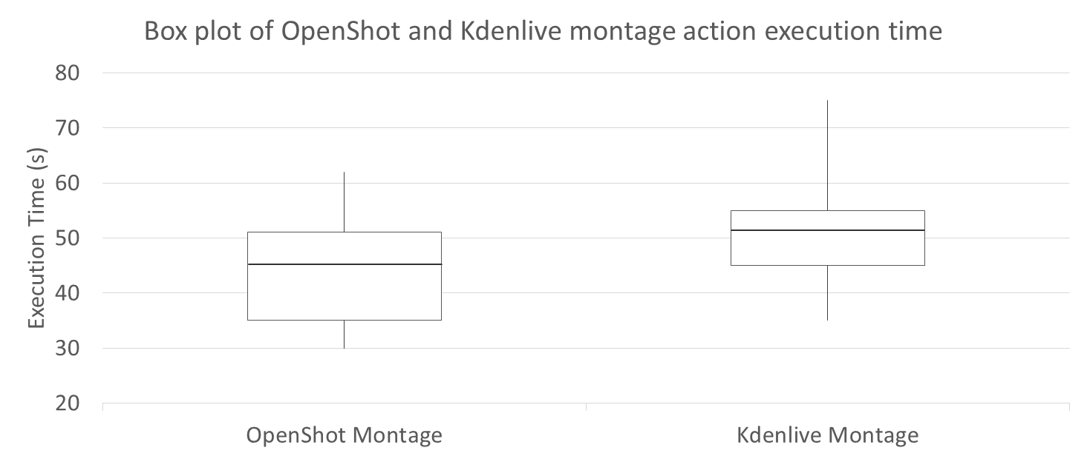

Figure 3: Box Plot of OpenShot and Kdenlive on Montage

As it can be seen in Figure 3, OpenShot gives better result on montage execution. Median value of OpenShot’s montage execution time is smaller than Kdenlive. Also slowest participant’s execution time is better in OpenShot. OpenShot is also gives better results on general distribution of execution time.

# Task Execution - Audio Effect

Audio effect action consists of adding audio effect to a video. We asked participants to add audio effects at specific time and duration on a video and measured the time it takes.

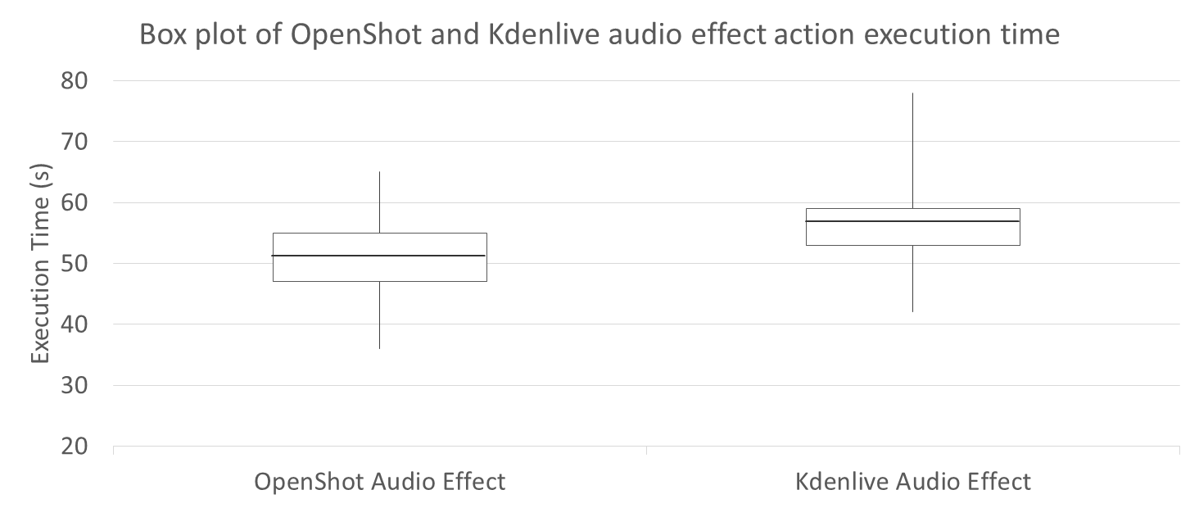

Figure 4: Box Plot of OpenShot and Kdenlive on Audio Effect

As it can be seen in Figure 4, OpenShot gives slightly better result on adding audio effect. Median value of OpenShot’s audio effect execution time is slightly smaller than Kdenlive. General distributions of audio execution time are close but again fastest and slowest OpenShot participants is much better than Kdenlive’s fastest and slowest participants. Difference between fastest and slowest participants are clear on this comparison.

# Task Execution - Video Effect

Video effect action consists of adding video effect to a video. We asked participants to add video effects at specific time and duration on a video and measured the time it takes.

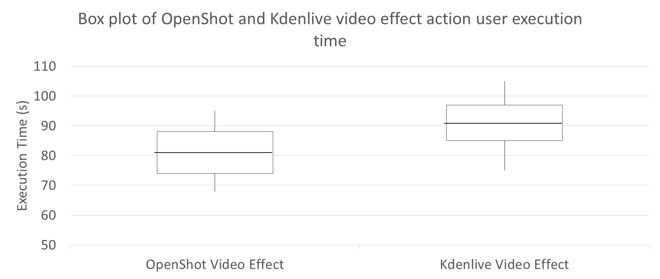

Figure 5: Box Plot of OpenShot and Kdenlive on Video Effect

As it can be seen in Figure 5, OpenShot gives clearly better result on adding video effect. Median value of OpenShot’s audio effect execution time is clearly smaller than Kdenlive. General distributions of audio execution time is way better than Kdenlive. Also fastest and slowest OpenShot participants is much better than Kdenlive’s fastest and slowest participants. Difference between median, fastest and slowest participants of video editing tools execution time are clear on this comparison.

# Task Execution – Toolbar Navigation

Toolbar navigation action is done to investigate software’s toolbar navigation usability. We asked participants to find a tool in toolbar menu and measure participant’s toolbar navigation time. Tools which are mostly used should be accessible in short time for usability.

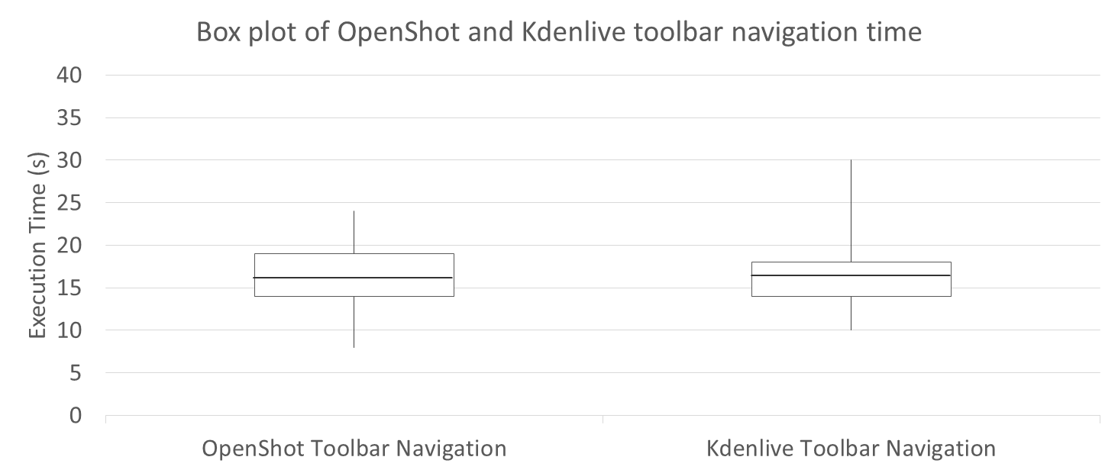

Figure 6: Box Plot of OpenShot and Kdenlive on Toolbar Navigation

As it can be seen in Figure 6, Kdenlive gives slightly better result in total on toolbar navigation but median values of OpenShot and Kdenlive toolbar navigation time are very close. Also general distributions of execution time are very close. Fastest participant results are also very close but OpenShot’s slowest participants are faster than Kdenlive’s slowest participants. In this category difference between tools are not so obvious but still we can say that Kdenlive gives slightly better result on toolbar navigation.

# Participant Feedback

In the stage of participant feedback, results are evaluated by considered criteria. There are six criteria to measure the usability of video editing tools. Learnability, flexibility, overall, compatibility, consistency, user guidance are the forms of criteria.

# Participant Feedback – Learnability

Learnability is one of the important criteria that is about adapting to a new software for a user. The reason why being easy learnability is an advantage is the time consumption. Usually, people spend a lot of time to learn the certain usage properties of the tool or to get used to the program. When the learnability is evaluated by participants, the result of the research will be like Figure 7.

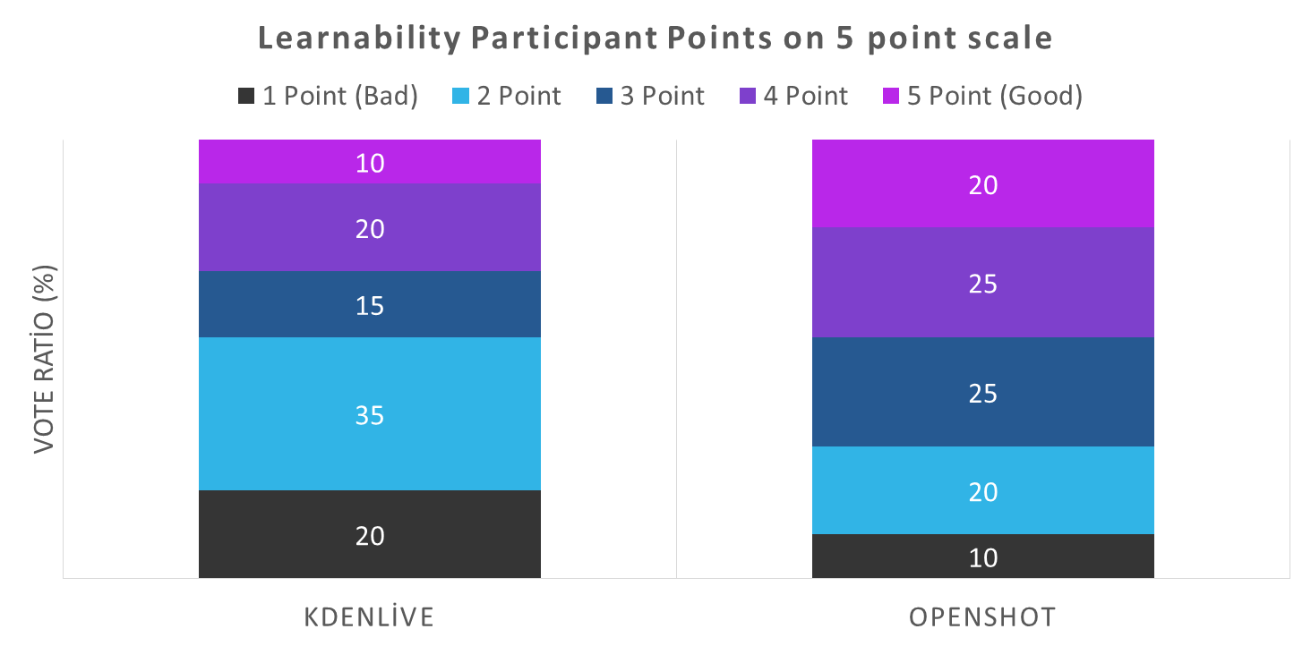

Figure 7: Participant Feedback Learnability

According to the figure, it is obvious to see that OpenShot is easy-learnable. Even if people scored the learnability of OpenShot equally almost in every level, it has higher points than Kdenlive. On the other hand, Kdenlive was evaluated one level up to the ‘bad’ by the majority of people. The results can show that Kdenlive has more complex interface than OpenShot.

# Participant Feedback – Flexibility

Flexibility is another essential property for users among all the other criteria and it provides to the user to complete the task easily and efficiently. To measure the flexibility of the software, the task is given to users and ask them to complete it. After finishing the task, users evaluate the program due to their struggling level while the program is running.

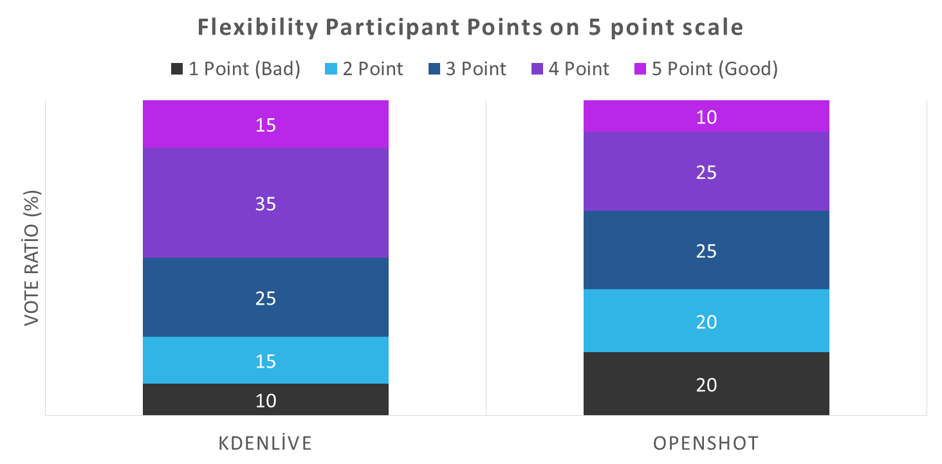

Figure 8: Participant Feedback Flexibility

Figure 8 indicates that Kdenlive has the higher points than OpenShot. It can be seen that people assessed Kdenlive closer to ‘good’, highest point while OpenShot has the minority on the highest point and its scores are almost equally divided by each level. Although there is no big difference in middle ratings, OpenShot has more points in lower levers.

# Participant Feedback – Overall

As it is mentioned before there are six criteria to choose the most usable software. Apart from considering flexibility and learnability separately, there is a general evaluation for these six criteria. According to general research about usability, OpenShot is chosen the most usable software among them. In addition, OpenShot has the bigger score on the one level under the highest point in contrast to Kdenlive. Also, the biggest parts of the score for Kdenlive are on the lowest level and one point above it.

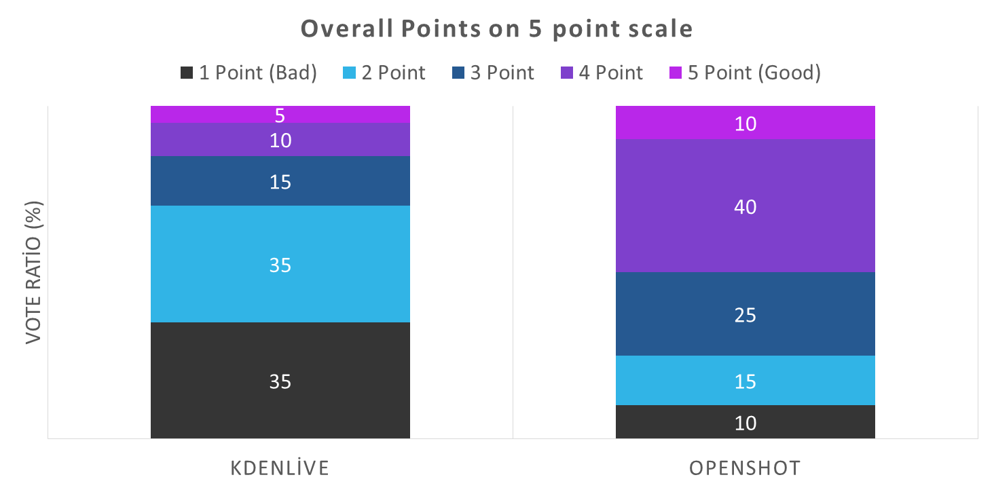

Figure 9: Participant Feedback Overall

After getting the overall evaluation, the most striking part is changeability in scores due to the type of criteria. In spite of the fact that for some important criteria, Kdenlive gets higher scores than OpenShot, OpenShot is still chosen more usable than Kdenlive with a big difference.

# Analysis

We compared and analyzed survey result after the survey data is collected. For survey results analyses, activity weights are determined according to their importance. Their weights are seen in Figure 10.

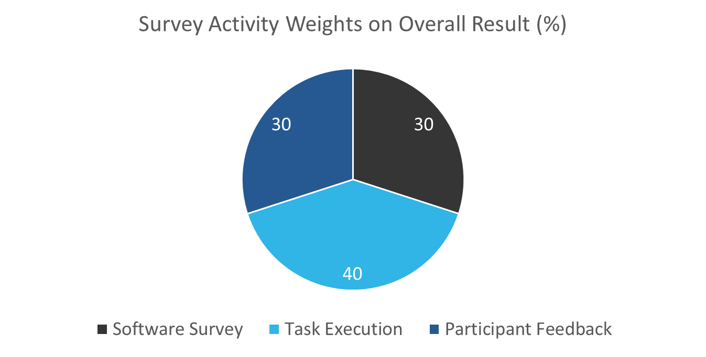

Figure 10: Survey activity weights on overall result

According to these weights, overall result calculation formula for one tool is:

**P = Software Survey * 0.3 + Task Execution * 0.4 + Participant Feedback * 0.3**

Total points for video editing tools:

**TOpenShot = POpenShot / (POpenShot + PKdenlive)**

**TKdenlive = PKdenlive / (POpenShot + PKdenlive)**

The results are carefully calculated from an Excel spreadsheet. The result can be seen below in Figure 11.

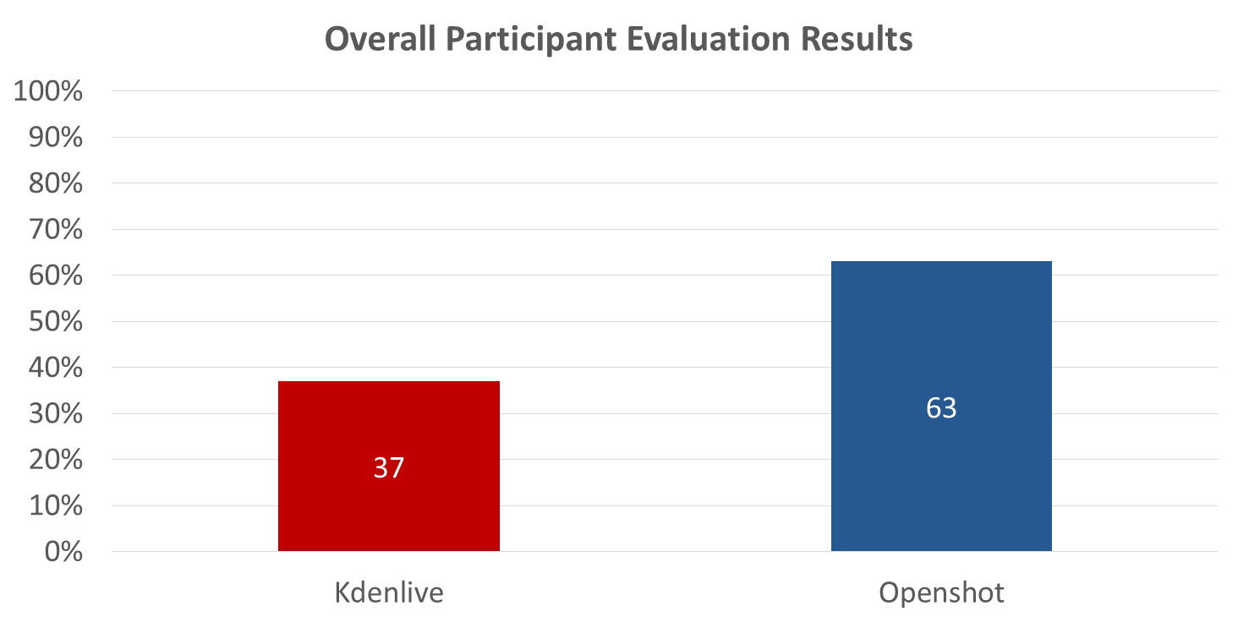

Figure 11: Overall Evaluation Result

After using the stated formula for calculation, it is apparent that OpenShot is better than Kdenlive. OpenShot in almost all of the tests performed better than Kdenlive. Nevertheless, Kdenlive is more flexible and enough for video editing process but OpenShot is perfect video editing tool for new video edit users. It can provide a video edit area with a very simple user interface. That is why according to our pie chart, with 63% overall performance OpenShot is recommended. Kdenlive is 37% which is 26% less than OpenShot. In the survey result, we see that the users preferred OpenShot’s interface much more and the results agree with the findings. OpenShot is more useful.

# Conclusion

7 participants surveyed Kdenlive and OpenShot open source video editing tools to determine usability performance of tools. Participants evaluated video editing tools on different tasks; montage (cut, copy, paste), video effect, audio effect, toolbar navigation. According to participants’ investigation, OpenShot is more usable as an open source video editing tool. In addition, learnability of OpenShot is better than Kdenlive but flexibility of Kdenlive is better than OpenShot. In conclusion, for It users, OpenShot is more useful and easier to learn.

# References

1. H. R. Hartson, T. S. Andre, and R. C. Williges, “Criteria For Evaluating Usability Evaluation Methods,” Int. J. Hum.-Comput. Interact., vol. 13, no. 4, pp. 373–410, 2001
2. OpenShot Features Web Page, OpenShot, http://www.openshot.org/features/
3. Kdenlive Features Web Page, Kdenlive, https://kdenlive.org/features

# Appendix

**Participant Survey**

Name:

……………………………………………………………………………………………………………………………………………………………………….

Surname:

……………………………………………………………………………………………………………………………………………………………………….

1. Do you have any prior experience about video editing tools?

YES NO

1. If you have any experience about video editing tools, have you ever used OpenShot or Kdenlive?

**Kdenlive**

YES NO

**OpenShot**

YES NO

1. For **Kdenlive:**
   1. Please rate usability for **Montage** (Cut, Copy and Paste) action.

1 (Very Poor) 2 (Poor) 3 (Fair) 4 (Good) 5 (Very Good)

* 1. Please rate usability for **Video Effect** action.

1 (Very Poor) 2 (Poor) 3 (Fair) 4 (Good) 5 (Very Good)

* 1. Please rate usability for **Audio Effect** action.

1 (Very Poor) 2 (Poor) 3 (Fair) 4 (Good) 5 (Very Good)

* 1. Please rate usability for **Toolbar Navigation** action.

1 (Very Poor) 2 (Poor) 3 (Fair) 4 (Good) 5 (Very Good)

1. For **OpenShot:**
   1. Please rate usability for **Montage** (Cut, Copy and Paste) action.

1 (Very Poor) 2 (Poor) 3 (Fair) 4 (Good) 5 (Very Good)

* 1. Please rate usability for **Video Effect** action.

1 (Very Poor) 2 (Poor) 3 (Fair) 4 (Good) 5 (Very Good)

* 1. Please rate usability for **Audio Effect** action.

1 (Very Poor) 2 (Poor) 3 (Fair) 4 (Good) 5 (Very Good)

* 1. Please rate usability for **Toolbar Navigation** action.

1 (Very Poor) 2 (Poor) 3 (Fair) 4 (Good) 5 (Very Good)